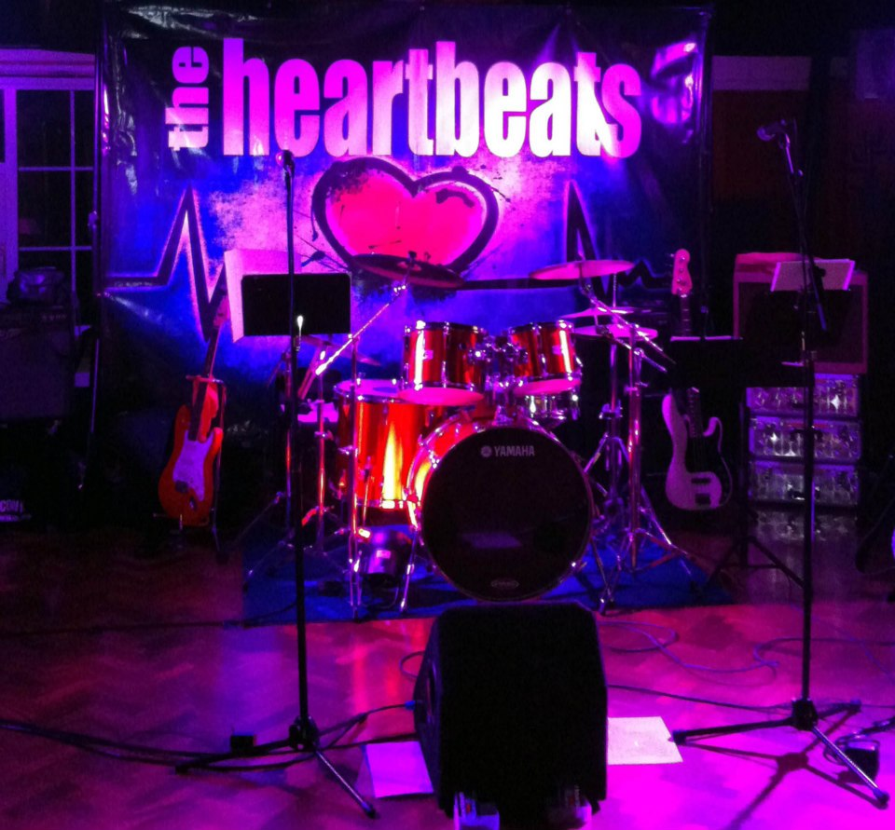
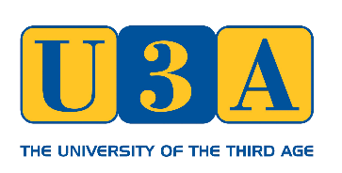

Book Now !
Fri 22 November @7.00 till 11.00
Kings Hill Community Centre
Featuring Kent’s premier live 1960s band, dancing, table quizzes,
non-alcoholic drinks &
more – just £9

BOOKING FORM for The Heartbeats

Your Name :

Email :

Tel :
Please email completed form to heartbeats@khu3a.club
or post to Joy Watson, 8 Bryant Close, Nettlestead, Maidstone ME18 5EX
£9 payment is due now, preferably by bank transfer to our account at:
Account: KHAD U3A Number: 00025484 Sort: 40 52 40 Ref: Heartbeats
Alternatively please send cheque payable to “Kings Hill & District U3A” to treasurer:
David Murray, 10 Crabtree Close, Kings Hill, ME19 4FR

